A PROJECT REPORT on

Design and Analysis of Individually Actuated

All-Terrain Vehicle

Submitted in partial fulfillment of the award of Degree of

Bachelor of Technology in Mechanical Engineering

Submitted by

Inzamamul Haq Roll No. – 12H61A03E6

Akhil Myadarapu Roll No. – 12H61A03F7

Anudeep Sunka Roll No. – 12H61A03G9

Shoba Tummati Roll No. – 12H61A03H0

Dheeraj Tippani Roll No. – 12H61A03H1

Under the Esteemed Guidance of

Dr. P. Ravikanth Raju, M.Tech, Ph.D.

Associate Professor

Department of Mechanical Engineering

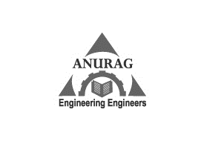

Anurag group of institutions

(an autonomous institution)

(Approved by AICTE, accredited by NBA & Affiliated to JNTU, Hyderabad)

Ghatkesar (M), Ranga Reddy (Dist.), Venkatapur, Telangana, 500088

2012-2016